**SYSTEM DEVELOPMENT PROJECT**

**ON**

#### MyLaundry

**(Web Based Application)**

**IN PARTIAL FULFILMENT OF**

**BACHELOR’S DEGREE IN COMPUTER APPLICATIONS (B.C.A.) GUJARAT UNIVERSITY (2020-2021)**

**SUBMITTED BY**

**101 Sirsolkar Abhishek Subhashbhai**

**105 Solanki Rohitkumar Manubhai**

**113 Thakkar Karan Dilipkumar**

**SOM-LALIT INSTITUTE OF COMPUTER APPLICATIONS**

**(*Affiliated to Gujarat University, BCA Programme)***

**SLIMS Campus, Nr. Xavier’s corner, University Road, Navrangpura,**

**Ahmedabad – 380 009.**

**SOM-LALIT INSTITUTE OF COMPUTER APPLICATIONS**

**(*Affiliated to the Gujarat University)***

**SLIMS Campus, Nr. St. Xavier’s Corner, University Road, Navrangpura,**

**Ahmedabad – 380009.**

**S L I C A**

**Phone: 26303301/2/3 Email:** [**info@somlalit.org**](mailto:info@somlalit.org) **Website:** [**www.somlalit.org**](http://www.somlalit.org/)

**CERTIFICATE**

This is to certify that SOFTWARE DEVELOPMENT PROJECT

**“MyLaundry**” is developed and submitted to Gujarat University by

**Mr. Sirsolkar Abhishek Subhashbhai**

**Mr. Solanki Rohitkumar Manubhai**

**Mr. Thakkar Karan Dilipkumar**

In partial fulfillment of the requirement for the award of the

**“Bachelor’s Degree in Computer Applications (B.C.A.)”**

in the year 2020-2021.

This is the original work and carried out under guidance and supervision.

We further certify that to the best of our knowledge and belief the matter

presented in this project report is bonafied.

**Name of guide I/c Director**

*Prof. Khyati Shah Mr. K. J.Patel*



**HASMUKH LAUNDRY SERVICES**

**ADDRESS :- SIR LAKHAJIRAJ ROAD ,**

**SANGANVA CHOWK , TRIKON BAG , RAJKOT –360007**

**CERTIFICATE**

This is to certify that

**Mr. Sirsolkar Abhishek Shubhash ,**

**Mr. Solanki RohitKumar ManuBhai** and

**Mr. Thakkar Karan DilipBhai**

Student of Som-Lalit Institute of Computer Application (SLICA),

Ahmedabad, has done and successfully completed their Software

Development Project Phase: 1

**“MYLAUNDRY”**

In our organization during 15th Jun 2020 to 20th Nov 2021.

Their work and conduct during the project was found very good.

We wish them all the best in their future endeavors.

**Date :** **Organization Seal** **Authorized Signatory**

 **mylaundrybusiness@gmail.com**

 **884905951**

# Acknowledgement

We extend our sincere thanks to our college “Som-Lalit Institute Of Computer Application (SLICA)”, our respected principal Mr. K. J. Patel, our respected faculties for giving us the golden opportunity to work on the project of “MYLAUNDRY” by providing us their precious time, deep and valuable knowledge to make project – a success.

We extend our warm thanks to our project guide Prof. Khyati Shah for her guidance and constant encouragement throughout the semester by providing their valuable time, advices for various problems whenever we needed for deciding the objectives of our report.

We extend our grateful thanks to Mr. Dilipbhai Thakkar, the owner of “Hashmukh Laundry Services”, for providing us the opportunity to work for their software creation of their Laundry Shop.

We express our thanks to our Parents, classmates and other external sources who helped us directly or indirectly.

Mr. Sirsolkar Abhishek S.

Mr. Solanki Rohit M.

Mr. Thakkar Karan D.

**INDEX**

**SR.NO. CONTENTS**

1. Introduction ………………………………………………………...
2. Company Profile …………………………………………………...
3. Process Description ………………………………………………...
4. Obstructions of Existing System …………………………………...
5. Proposed System ……………………………………………………
6. Objectives Of Proposed System ……………………………………
7. Hardware and Software Requirement ………………………………
8. Inputs ……………………………………………………………….
9. Outputs ……………………………………………………………...
10. Entity Relationship Diagram ………………………………………..
11. UML Diagram ………………………………………………………
    1. Use –Case Diagram ……………………………………
    2. Class Diagram …………………………………………
    3. Object Diagram ………………………………………..
    4. Sequence Diagram …………………………………….
    5. Collaboration Diagram ………………………………...
    6. Activity Diagram ………………………………………
    7. State –Chart Diagram
12. Data Dictionary ……………………………………………………….
13. Bibliography …………………………………………………………..

­­­

# **Introduction**

* MyLaundry will be website that helps customer to select packages (yearly , monthly) or service (e.g. Wash , iron and dry cleaning) and it will also provide pickup and delivery from customer home.
* It will also help admin manage customer details, order details and keep records of customers , services and package online.

# **Company Profile**

|  |  |
| --- | --- |
| Company Name : | Hashmukh Laundry Services |
| Address : | Sir Lakhajiraj Road, Sanganva Chowk, Trikon Baag, Rajkot-360 007 |
| Contact No. : | +91 8849059151 |
| Email Id : | [mylaundrybusiness@gmail.com](mailto:mylaundrybusiness@gmail.com) |
|  |  |

* **Process Description**

* **Existing System**
* In the existing system all transaction & dealings of orders are done manually & Invoice is hand written.

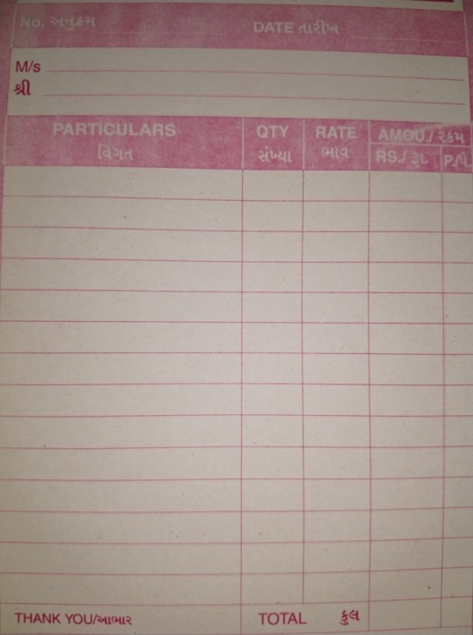 

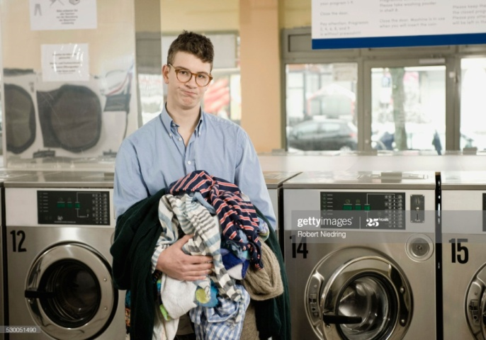

* **Limitations of Existing System**
* Customers have to visit the shop to get the details for the order and it is time consuming.
* Maintaining customer information is a tedious because of paper work.
* No records are maintained for customer’s feedback & rating.
* Customer can't check the status of their order.
* Report can’t be generated.
* Customers have to visit the shop to get and give clothes, pay and get bills.

# **Proposed System**

* Proposed system has 4 users:
  + - 1. Admin
      2. Employee
      3. Customer
      4. Visitor
* **Admin**
* Login
* Manage Profile
* Manage Employee Details
* Manage Customer Details
* Manage Appointments
* Manage Order Details
* Manage Services Details
* Manage Package(monthly , yearly)
* Manage Offers & Discount
* Manage Cloth’s type price list
* Manage Complains & Queries
* Generate Invoice
* View Ratings & Feedback
* Send Notification to Customer
* Generate Report

## Employee

## Login

## Manage Profile

## View Customer Details

## View Appointment

## Pick-Up Cloth From Customer Home

## View Order Details

## Manage Order Status

## Customer

* Login
* Manage Profile
* View and search package & services details
* Select Packages & Services
* Take Appointment
* View Cloth type & Price List
* View Offers & Discount
* Manage Cart
* Place Orders
* View Order history
* View Order Status
* Give feedback & Rating
* Get an e-Invoice
* Send Complaints & Queries
* Receive notification from Admin

## Visitor

* Registration As customer
* View and search services & Packages
* Send Inquiry
* View Complain & Queries
* View Rating & Feedback

# **Objectives of Proposed System**

* Customer can see and give orders from any place any time using internet.
* Admin can easily maintain all the detail of customer and order.
* Customer can select individuals services and packages as per their requirements.
* Feedbacks and ratings given by customers can be easily recorded.
* Provide more reach and ease of management to the Laundry.
* Reports can be easily generated.

# 

# **Hardware and Software Requirement**

* **Hardware:**
* Processor : Intel Core i3
* RAM : 4 GB
* Hard Disk : 1TB
* **Software:**
* Front End : ASP.NET
* Operating System : Windows 10
* IDE : Microsoft Visual Studio 2010
* Back End : SQL Server 2008
* Framework : .Net Framework 4.0
* Web Server : IIS
* Presentation Tool : Microsoft PowerPoint2016
* Diagram Tool : Visual Paradigm 8.0
* Programming Language : C#

## Inputs :

* Customer Details
* Employee Details
* Service Details
* Appointment Details
* Order Details
* Cloth type & Price List
* Package Details
* Delivery Details
* Feedback & Rating
* Complain & Queries

## Outputs :

* Customer detail (Area Wise)
* Employee detail
* Order Report
* Appointment Report (daily , weekly)
* Cloth type price list Report
* Package detail
* Invoice
* Delivery Report

# **Entity Relationship**

# **Diagram**

# **Entity Relationship Diagram.png**

# **Use-Case Diagram:**

# **Use Case Diagram2.png**

# **Admin :**

# **Admin UseCase.png**

# **Customer :**

# **Customer UseCase.png**

* **Employee :**

**    **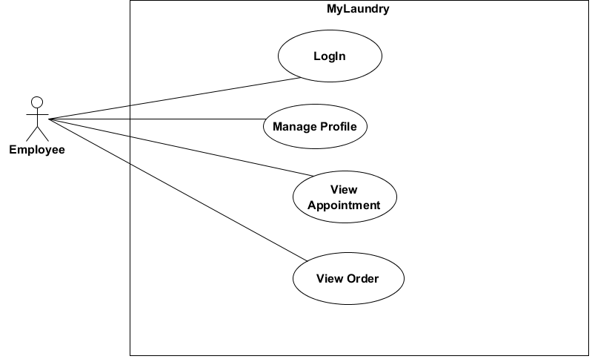

* **Visitor :**

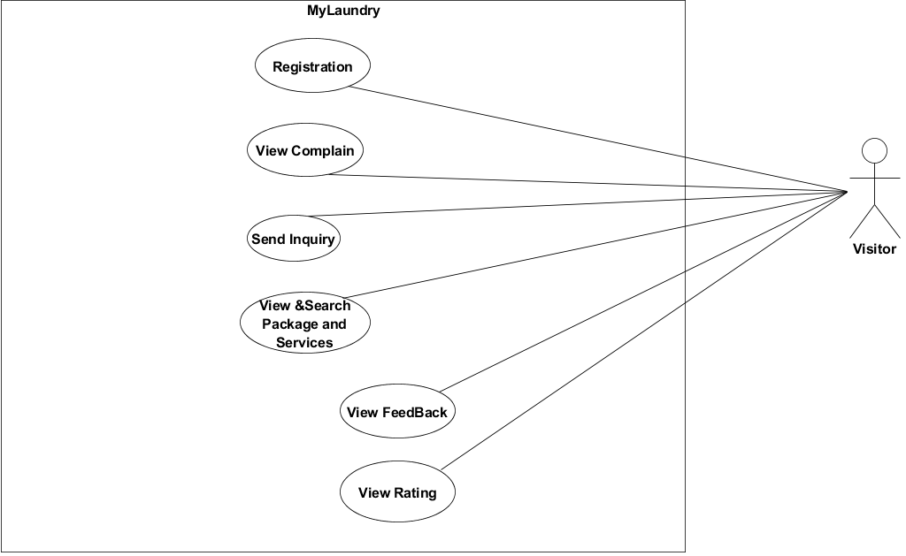

* **Class Diagram :**

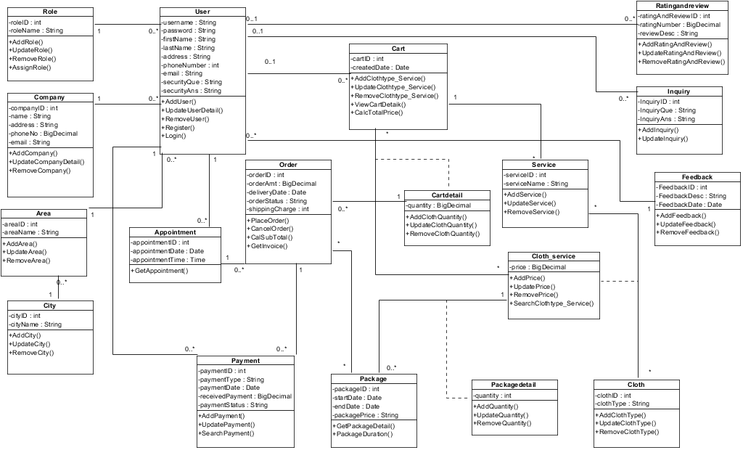

* **Object Diagram :**

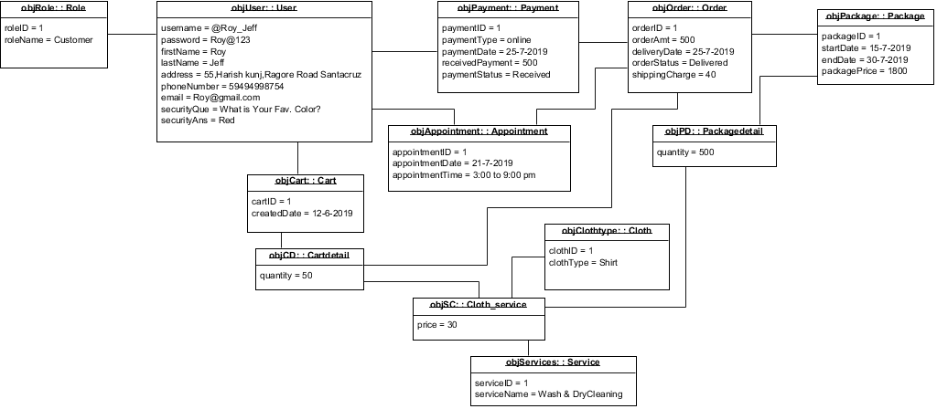

* **Sequence Diagram :**
* **Registration :**

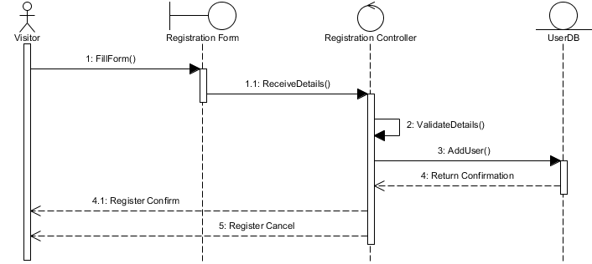

* **Login :**

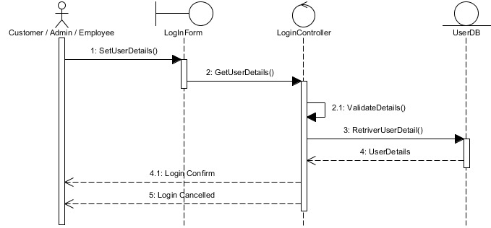

* **Manage Profile :**

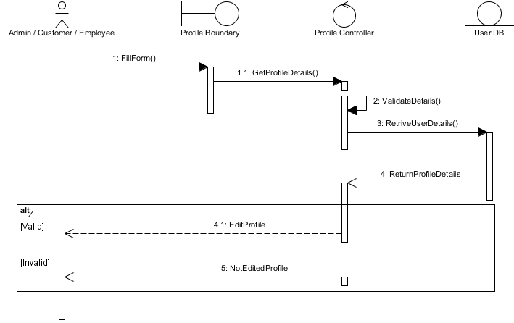

* **Appointment :**

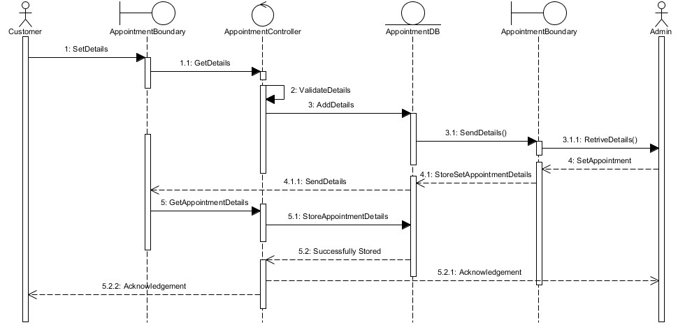

* **Manage Cart :**

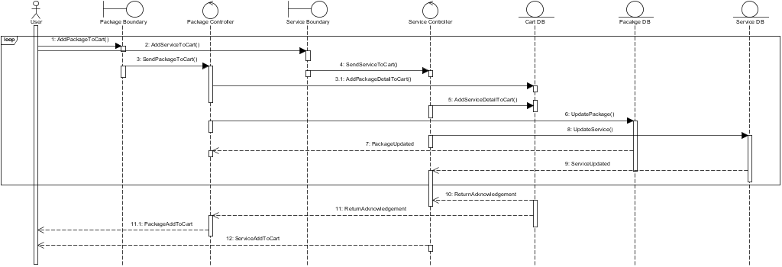

* **Place Order :**

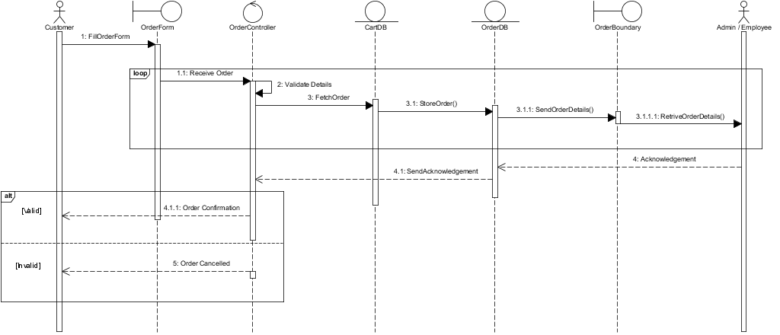

* **Payment :**

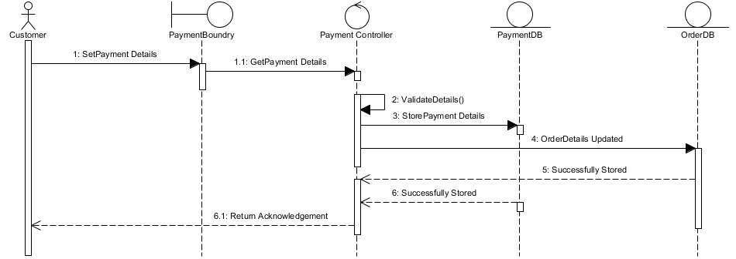

* **View & Search Packages And Services :**

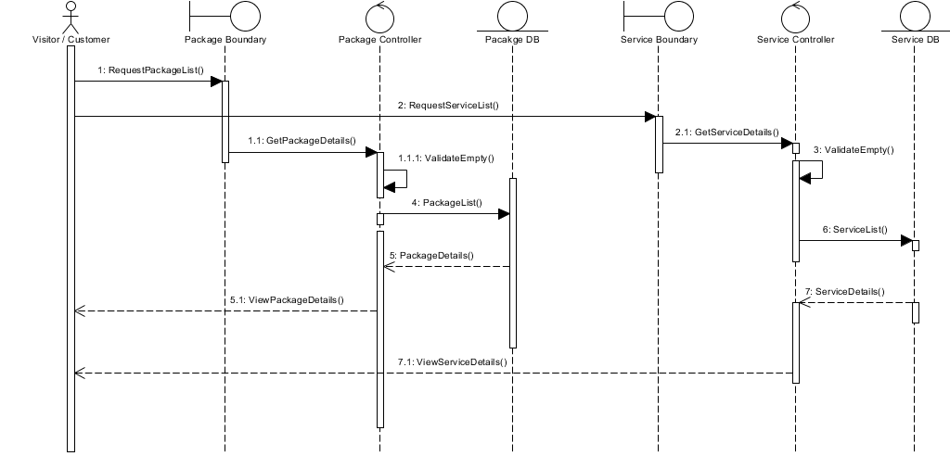

* **View Cloth & Pricelist :**

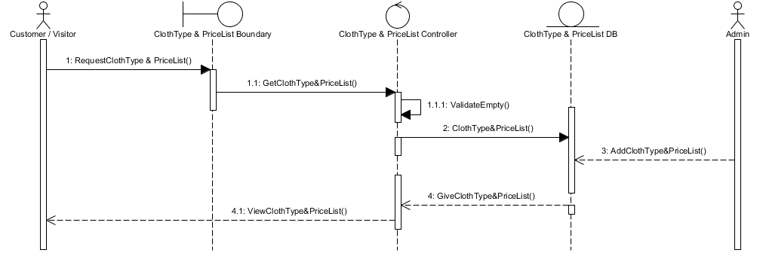

* **Select & Manage Packages :**

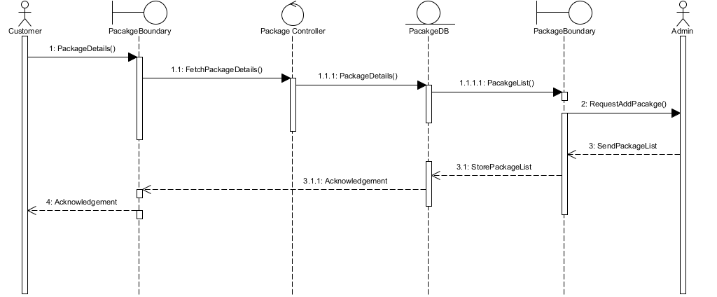

* **Select & Manage Services :**

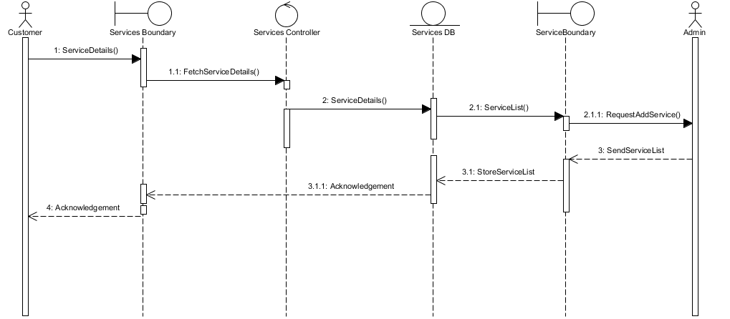

* **Feedback :**

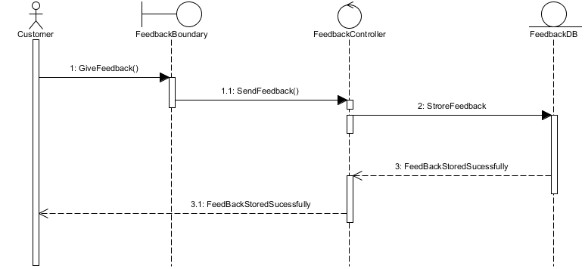

* **View Feedback :**

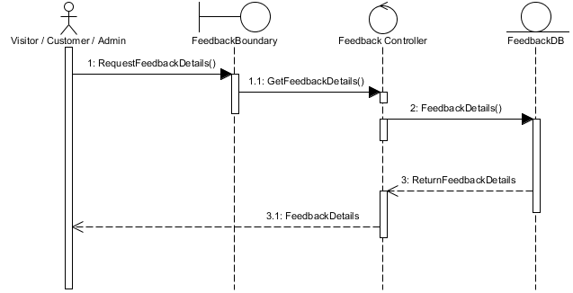

* **Rating :**

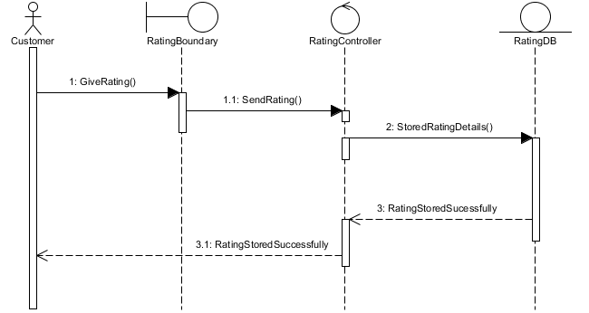

* **View Rating :**

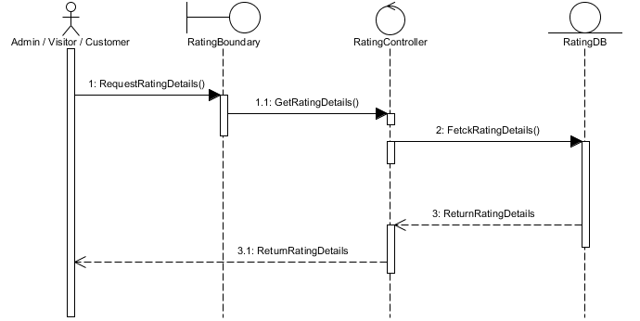

* **Inquiry :**

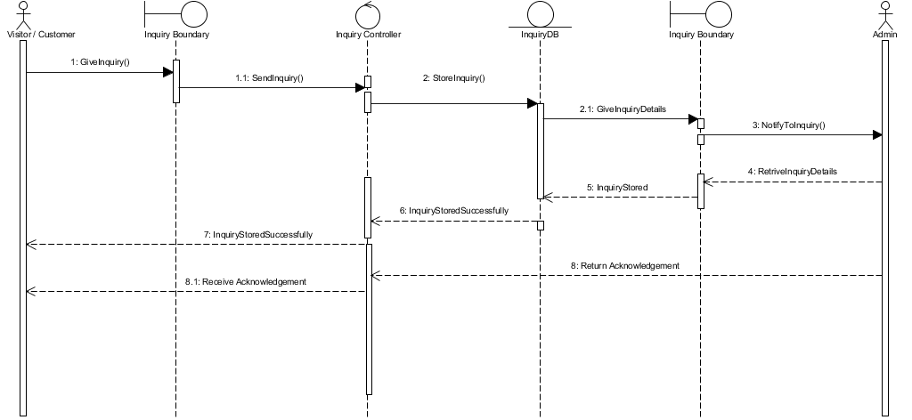

* **Collaboration Diagram :**
* **Registration :**

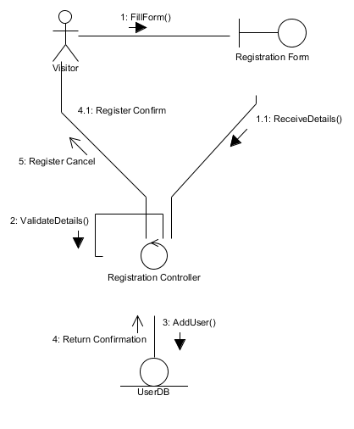

* **Login :**

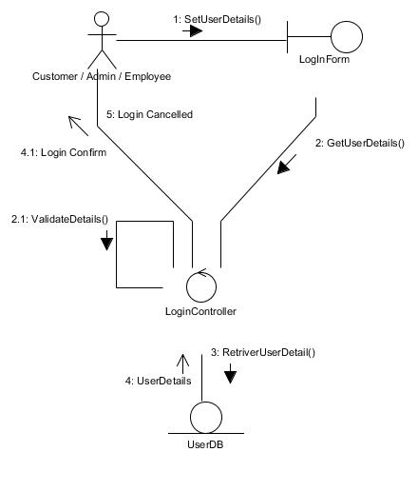

* **Manage Profile :**

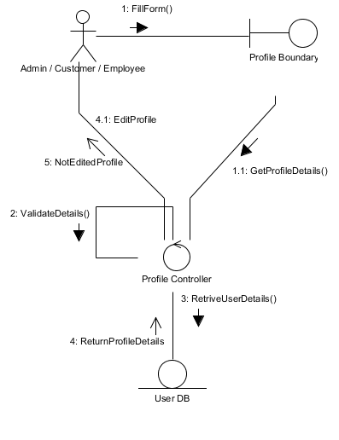

* **Appointment :**

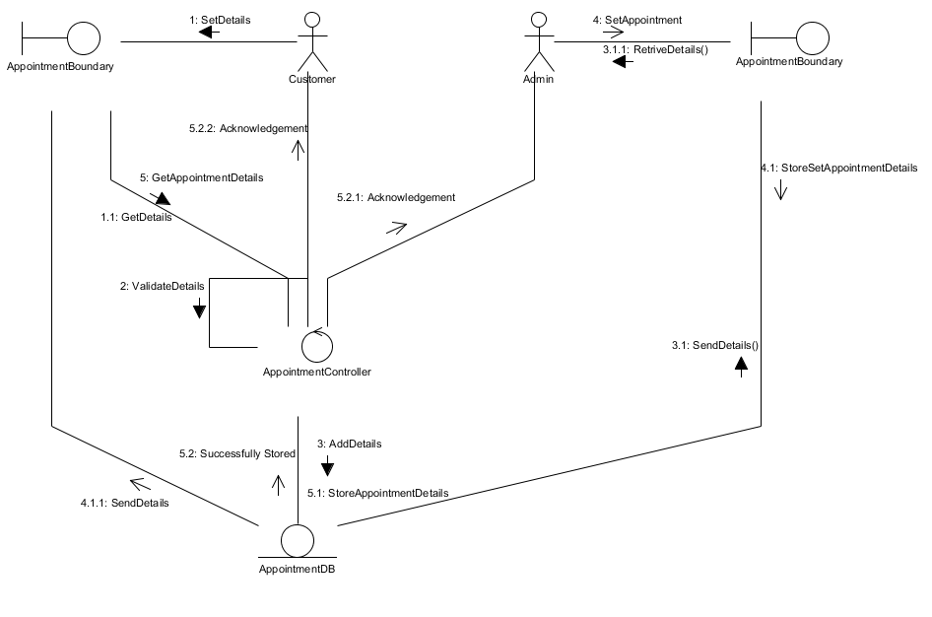

* **Manage Cart :**

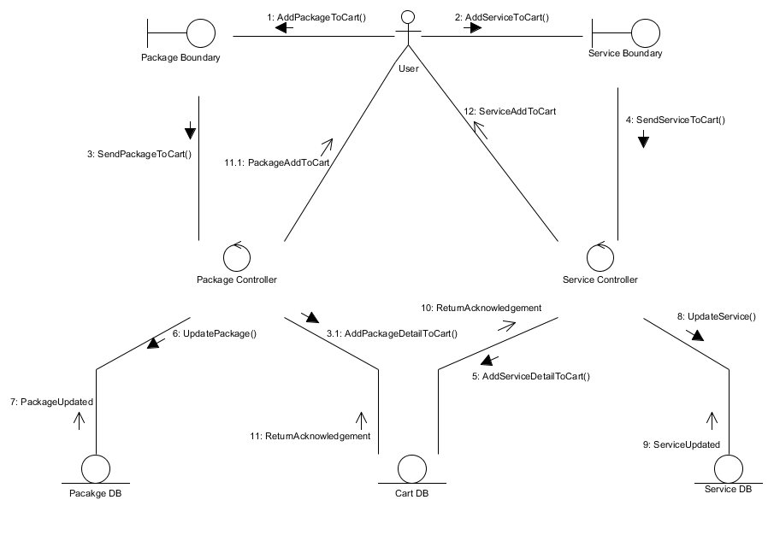

* **Place Order :**

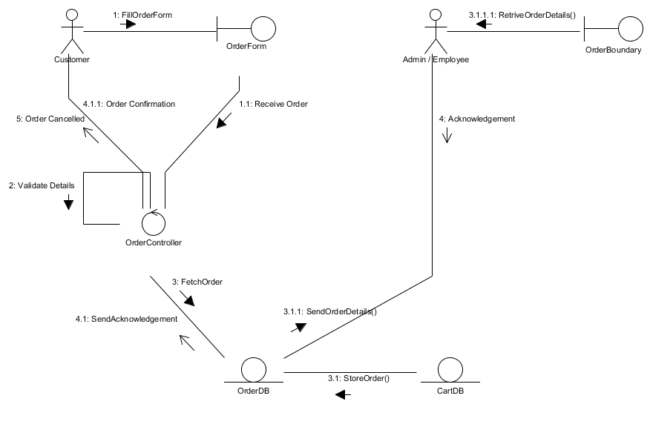

* **Payment :**

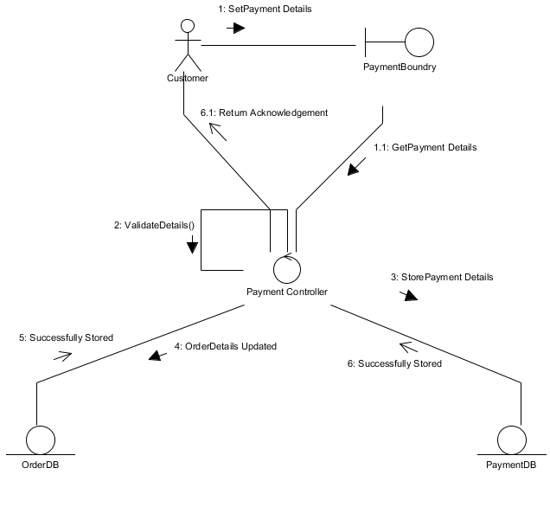

* **View & Search Packages And Services :**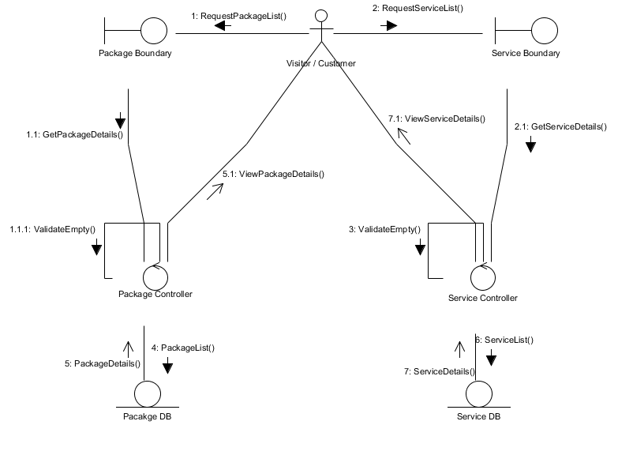
* **View Cloth & Pricelist :**

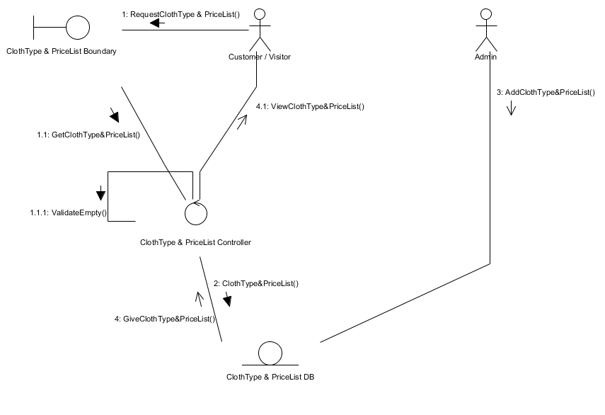

* **Select & Manage Packages :**

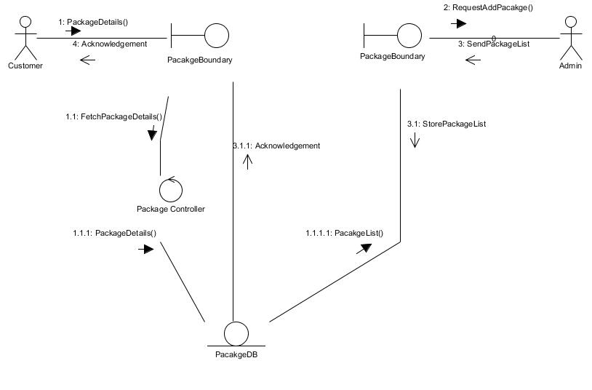

* **Select & Manage Services :**

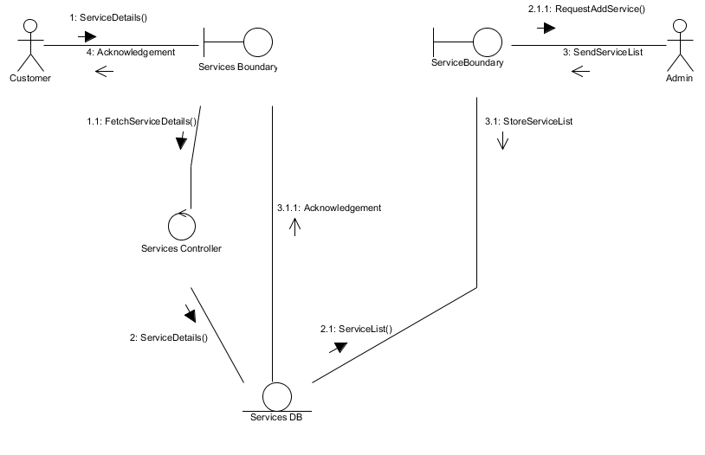

* **Feedback :**

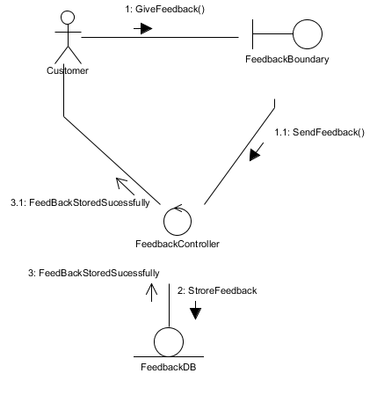

* **View Feedback :**

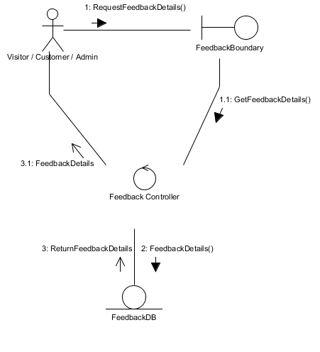

* **Rating :**

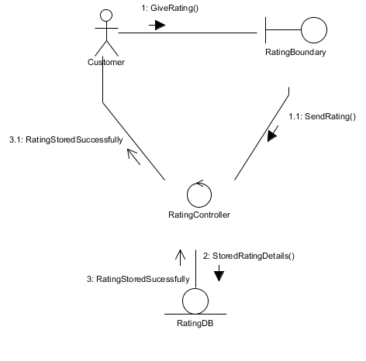

* **View Rating :**

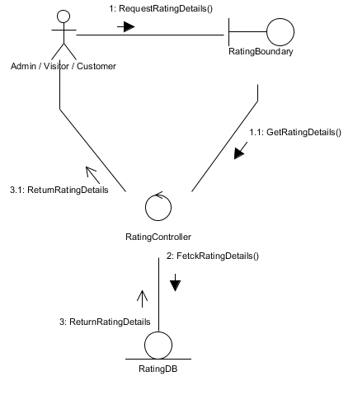

* **Inquiry :**

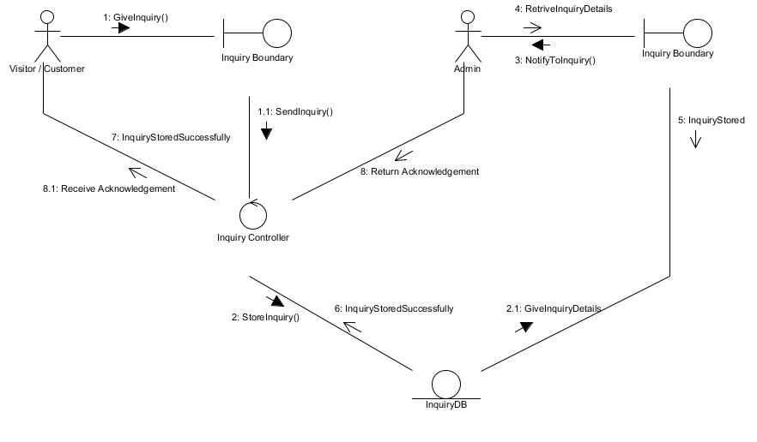

* **Activity Diagram :**

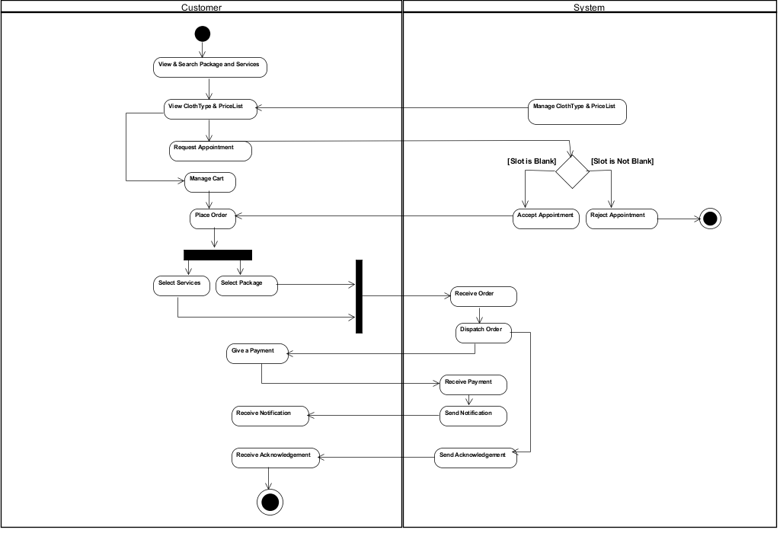

* **State Diagram :**

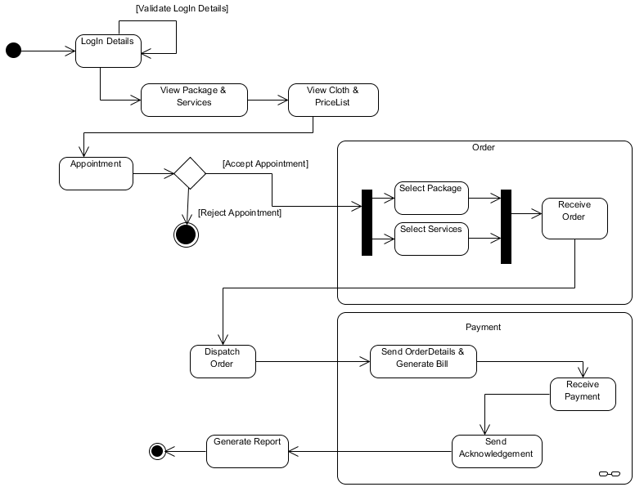

# **Data Dictionary :**

# **Role :** This table will store details of Role.

|  |  |  |  |
| --- | --- | --- | --- |
| **Field Name** | **Data Type** | **Constraints** | **Description** |
| RoleID | Integer | Primary Key | Id of Role |
| RoleName | Varchar(15) | Not Null | Name of Role |

* **Company :** This table will store details of

Company.

|  |  |  |  |
| --- | --- | --- | --- |
| **Field Name** | **Data Type** | **Constraints** | **Description** |
| CompanyID | Integer | Primary Key | Id of Company |
| Name | Varchar(15) | Not Null | Name of Company |
| Address | Varchar(100) | Not Null | Company Address |
| PhoneNo | Numeric(13) | Not Null | Phone Number |
| Email | Varchar(25) | Not Null | Email Address |

* **City :** This table will store details of City.

|  |  |  |  |
| --- | --- | --- | --- |
| **Field Name** | **Data Type** | **Constraints** | **Description** |
| CityID | Integer | Primary key | Id of City |
| CityName | Varchar(15) | Not Null | Name of City |

* **Area :** This table will store details of Area.

|  |  |  |  |
| --- | --- | --- | --- |
| **Field Name** | **Data Type** | **Constraints** | **Description** |
| AreaID | Integer | Primary key | ID of Area |
| AreaName | Varchar(15) | Not Null | Name of Area |
| CityID | Integer | Foreign key | ID of City |

* **User :** This table will store details of User.

|  |  |  |  |
| --- | --- | --- | --- |
| **Field Name** | **Data Type** | **Constraints** | **Description** |
| UserName | Varchar(15) | Primary key | Login Username |
| Password | Varchar(20) | Not Null | Login Password |
| FirstName | Varchar(15) | Not Null | User’s First Name |
| LastName | Varchar(15) | Not Null | User’s Last Name |
| Address | Varchar(100) | Not Null | User’s Address |
| PhoneNumber | Numeric(13) | Not Null | User’s Phone Number |
| Email | Varchar(25) | Not Null | Email Address |
| SecurityQue | Varchar(100) | Not Null | Security Question |
| SecurityAns | Varchar(100) | Not Null | Security Answer |
| RoleID | Integer | Foreign key | ID of Role |
| CompanyID | Integer | Foreign key | ID of Company |
| AreaID | Integer | Foreign key | ID of Area |

* **Cloth :** This table will store details of Cloth.

|  |  |  |  |
| --- | --- | --- | --- |
| **Field Name** | **Data Type** | **Constraints** | **Description** |
| ClothID | Integer | Primary Key | Id of Cloth |
| Cloth | Varchar(15) | Not Null | Type of Cloth |

* **Service :** This table will store details of

Services.

|  |  |  |  |
| --- | --- | --- | --- |
| **Field Name** | **Data Type** | **Constraints** | **Description** |
| ServiceID | Integer | Primary key | Id of Service |
| Servicename | Varchar(15) | Not Null | Name of Service |

* **Cloth_Service :** This table will store details of Cloth and Service tables (Bridge Table).

|  |  |  |  |
| --- | --- | --- | --- |
| **Field Name** | **Data Type** | **Constraints** | **Description** |
| ClothID | Integer | Primary Key + Foreign key | Id of Cloth |
| ServiceID | Integer | Primary Key + Foreign key | Id of Service |
| Price | Numeric | Not Null | Price |

* **Package :** This table will Store details of Package.

|  |  |  |  |
| --- | --- | --- | --- |
| **Field Name** | **Data Type** | **Constraints** | **Description** |
| PackageID | Integer | Primary key | ID of Package |
| StartDate | Date | Not Null | Package Start Date |
| EndDate | Date | Not Null | Package End Date |
| PackagePrice | Numeric | Not Null | Price of Package |

* **Cart :** This table will store details of Cart.

|  |  |  |  |
| --- | --- | --- | --- |
| **Field Name** | **Data Type** | **Constraints** | **Description** |
| CartID | Integer | Primary Key | Id of Cart |
| CreatedDate | Date | Not Null | Cart Created Date |
| Username | Varchar(15) | Foreign Key | Reference of User |

* **CartDetails :** This table will store details of Cart

and Cloth_Service tables (Bridge

Table).

|  |  |  |  |
| --- | --- | --- | --- |
| **Field Name** | **Data Type** | **Constraints** | **Description** |
| CartID | Integer | Primary Key + Foreign Key | Id of Cart |
| ClothID | Integer | Primary Key + Foreign Key | Id of ClothType |
| ServiceID | Integer | Primary Key + Foreign Key | Id of Service |
| Quantity | Numeric | Not Null | Quantity |

* **PackageDetails :** This table will store details of

Package and Cloth_Service

(Bridge Table).

|  |  |  |  |
| --- | --- | --- | --- |
| **Field Name** | **Data Type** | **Constraints** | **Description** |
| PackageID | Integer | Primary key + Foreign key | Id of Package |
| ClothID | Integer | Primary key + Foreign key | Id of ClothType |
| ServiceID | Integer | Primary key + Foreign key | Id of Service |
| Quantity | Numeric | Not Null | Quantity of Order |

* **Appointment :** This table will store details of

Appointment.

|  |  |  |  |
| --- | --- | --- | --- |
| **Field Name** | **Data Type** | **Constraints** | **Description** |
| AppointmentID | Integer | Primary Key | Id of Appointment |
| AppointmentDate | Date | Not Null | AppointmentDate |
| AppointmentTime | Time | Not Null | AppointmentTime |
| Username | Varchar(15) | Foreign key | Reference of User |

* **Order :** This table will store details of Order.

|  |  |  |  |
| --- | --- | --- | --- |
| **Field Name** | **Data Type** | **Constraints** | **Description** |
| OrderID | Integer | Primary Key | Id of Order |
| OrderAmt | Numeric | Not Null | Amount Ordered |
| DeliveryDate | Date | Not Null | Date of Delivery |
| OrderStatus | Varchar(10) | Not Null | Status of Order |
| ShippingCharge | Numeric | Not Null | Charge of Shipping |
| AppointmentID | Integer | Foreign key | Id of Appointment |
| PackageID | Integer | Foreign key | Id of Package |
| CartID | Integer | Foreign key | Id of Cart |

* **Inquiry :** This table will store details of Inquiry.

|  |  |  |  |
| --- | --- | --- | --- |
| **Field Name** | **Data Type** | **Constraints** | **Description** |
| InquiryID | Integer | Primary Key | Id of Inquiry |
| InquiryQue | Varchar(100) | Not Null | Inquiry Question |
| InquiryAns | Varchar(100) | Not Null | Answer for Inquiry |
| Username | Varchar(15) | Foreign key | Reference of User |

* **Payment :** This table will store details of Payment.

|  |  |  |  |
| --- | --- | --- | --- |
| **Field Name** | **Data Type** | **Constraints** | **Description** |
| PaymentID | Integer | Primary key | Id of Payment |
| PaymentType | Varchar(15) | Not Null | Type of Payment |
| PaymentDate | Date | Not Null | Date of Paying |
| RecievedPayment | Numeric | Not Null | Amount Paid |
| PaymentStatus | Varchar(20) | Not Null | Status of Payment |
| Username | Varchar(15) | Foreign key | Reference of User |
| CartID | Integer | Foreign key | Id of Cart |

* **Rating&Review :** This table will store details of

Rating And Review.

|  |  |  |  |
| --- | --- | --- | --- |
| **Field Name** | **Data Type** | **Constraints** | **Description** |
| RatingAndReviewID | Integer | Primary key | Id of Rating and Review |
| RatingNumber | Numeric | Not Null | Number of Rating |
| ReviewDesc | Varchar(100) | Not Null | Review Description |
| Username | Varchar | Foreign key | Reference of User |

* **Feedback :** This table will store details of Feedback.

|  |  |  |  |
| --- | --- | --- | --- |
| **Field Name** | **Data Type** | **Constraints** | **Description** |
| FeedbackID | Integer | Primary key | Id of Feedback |
| FeedBackDesc | Varchar(100) | Not Null | Feedback Description |
| FeedBackDate | Date | Not Null | Date of Feedback |

* **Bibliography :**
* **Reference Books :**
  + **Object Oriented Analysis And Design**
  + **Database System Concepts**
  + **Database Management System-II**
* **Reference Website :**
  + [**https://www.mssqltips.com**](https://www.mssqltips.com/)
  + [**https://stackoverflow.com**](https://stackoverflow.com/)
  + [**https://w3schools.com**](https://w3schools.com/)